Server 2022 Worksheet
The purpose of this worksheet is to guide you towards successfully promoting your Server 2022 to an Active Directory (AD) Domain Controller

Instructions
- Start your Server 2022 virtual machine. You can use either your VirtualBox installation or your Team Server on ProxMox.
  - If you are using VirtualBox, make sure Server 2022 is connected to the same NAT Network you used in the previous project (week 3-project #8).
    - If it isn’t, go to the VM’s settings and change the network adapter to use the correct NAT Network.
  - Optional: check your Windows 11 VM’s network settings and make sure it is connected to the same NAT Network. It doesn’t need to be powered on for this project.
- Open a Command Prompt and take a screenshot of ipconfig results.

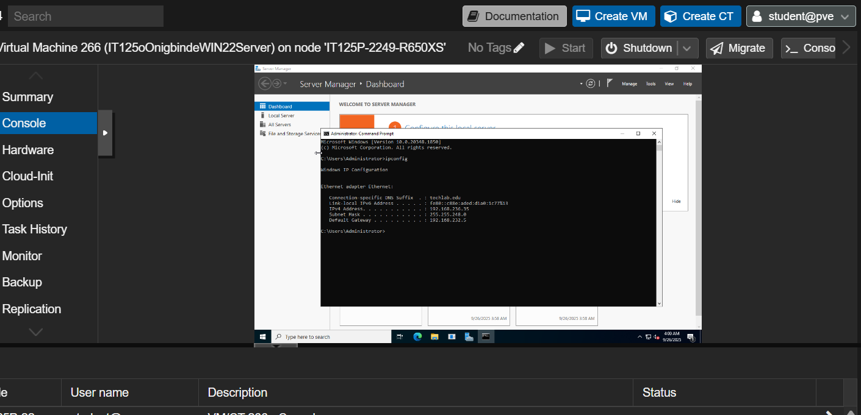
- Open Server Manager and open the Local Server page. Take a screenshot of the Local Server page.
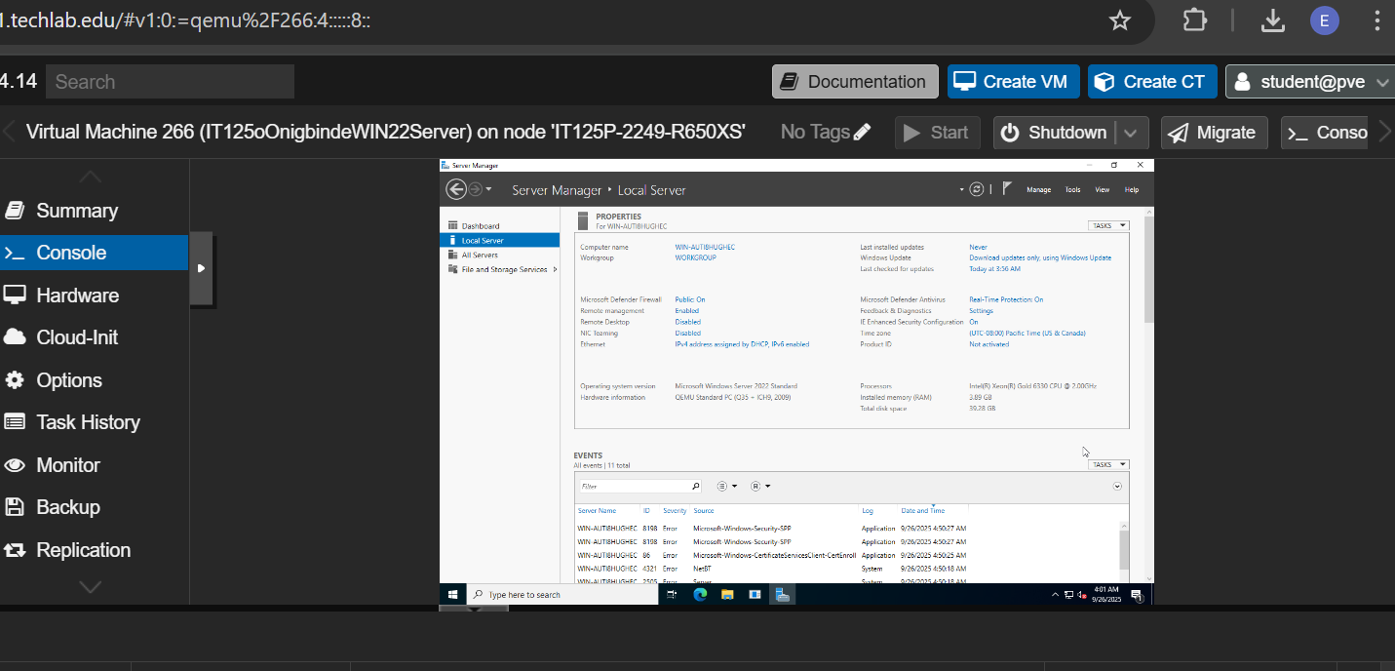

- Promote your server to a Domain Controller by creating a new Active Directory (AD) Domain.
  - You can name your domain anything you choose.
  - Keep the domain name 15 characters or fewer, and use a .local or .internal suffix (e.g., Team1.local).
  - If you are using ProxMox, make sure all group members are monitoring the promotion.
  - If you have done this before and feel confident, proceed. Otherwise, reference an online tutorial for creating an Active Directory (AD) Domain. Here are two suggestions:
    - Read: Promote a Server to a Domain Controller (URL: (https://www.serveracademy.com/blog/promote-a-server-to-a-domain-controller/)
    - Watch: How to promote Windows Server 2022 to be a Domain Controller.
  - If you have any problems, please communicate with the instructor or fellow students!
- Take a screenshot of the Local Server page from Server Manager after creating your domain controller.
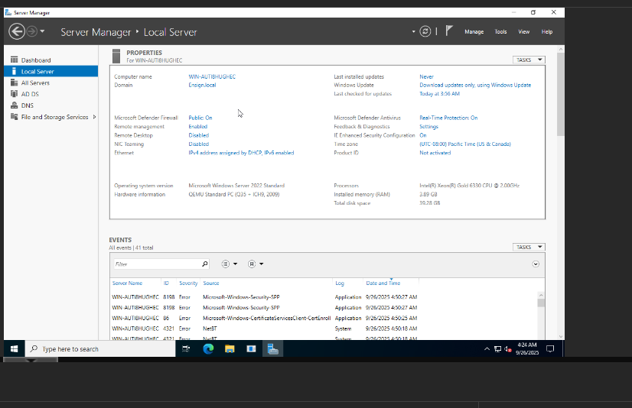

- Save and submit this completed worksheet in Canvas. Be sure you have included all of your required screenshots (steps 2, 3, and 5).

